The UI and flow needs work. Lets spend some time to make it polished:
SIDEBAR
Right now the SideBar looks like this:
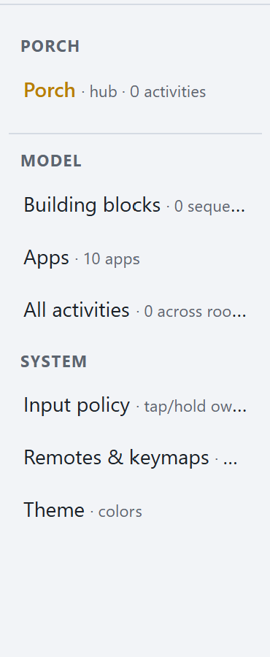
I think it’s confusing.
How about:
VIEWS
Home
Porch
Porch HVAC
Deck
CONTROLLERS
MA Media Player
TV Media Player
Climate
Light
Cover
Etc…

MODEL
Actions
SYSTEM
…
TAXONOMY:
- A view, is a collection of activities, devices and presets (formally called hub).
- A controller, is a page that provides a control surface for a device or device group

VIEWS
- Metadata about the view (name, id)
Currently:
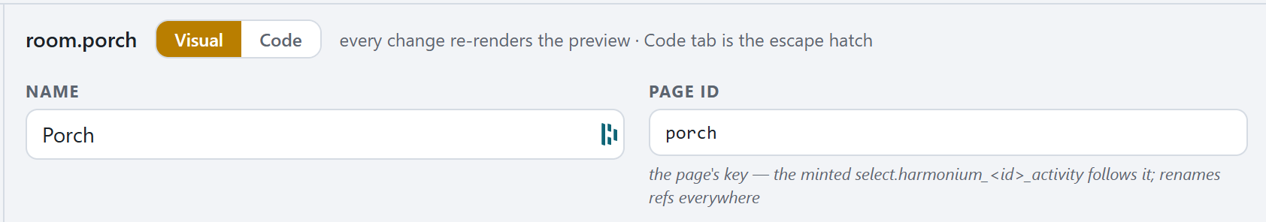
But we should change room.porch to view.porch and view id should therefore default to porch (what if its already in use?).
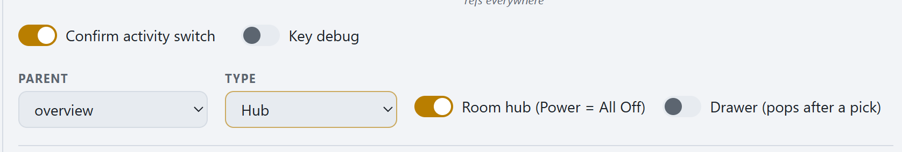
Rather then say PARENT, We should say HOME KEY, Type seems redundant.
And we should make this key centric.
i.e.
KEY MAPPINGS:
Back: Nothing Home: page:overview Power: Smart Power (discuss)

  - HERO CARD
Perfect as is.

  - ACTIVITIES
Start and Stop Action remain a bit clunky.
- Yes, I want to be able to select an existing action.
- But if I want to create a new one, the current flow is not great. It takes me to the sequences page with an auto-named new activity and no way of getting back! It also auto populates the parent Start Action, so I can’t delete the action and start over with out returning to the view, setting it to none and going back.
Quickest fix for now would be (a) a Confirm Action or something in the sequence editor title, and only then do we update the Start Action and return to the view page where we left it. AND at the sequence page level, a Back button.
- I think we overhaul navigate to. It should default to a controller. (we can guess the controller from the primary device type – user can override. We also support navigate to pages/views.
- If we choose controller, an accordion appears of controller specific settings.

